Algorithm Analysis Fundamentals
Time complexity analysis of iterative and recursive algorithms; verify Big-O, Ω, Θ for sample programs

Experiment 1: Linear Search (Iterative)

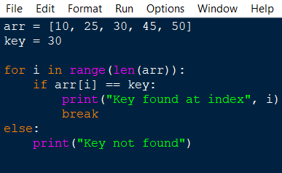

OUTPUT:
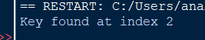

Experiment 2: Binary Search (Recursive)
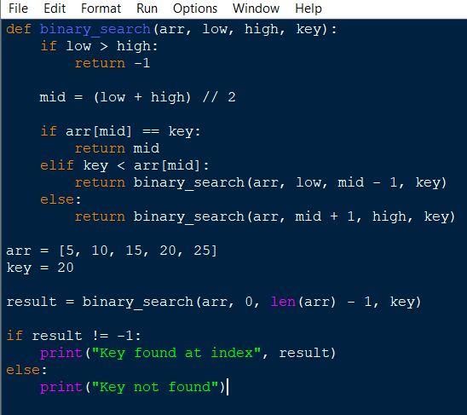

OUTPUT:
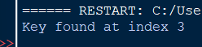

Experiment 3: Factorial (Iterative vs Recursive)
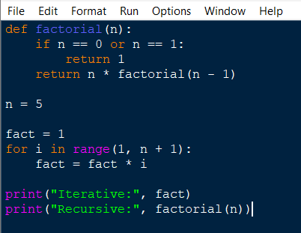

OUTPUT:
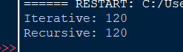

Experiment 4: Fibonacci Series
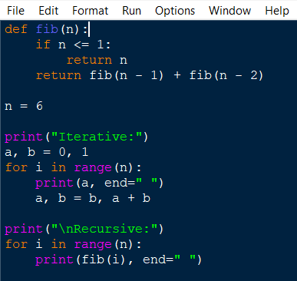

OUTPUT:
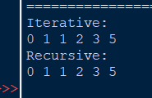

Experiment 5: Matrix Multiplication
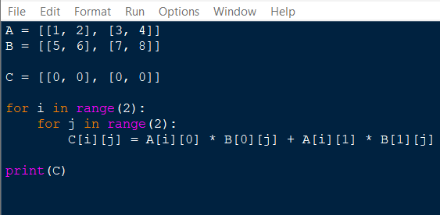

OUTPUT:
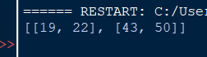

Experiment 6: Merge Sort
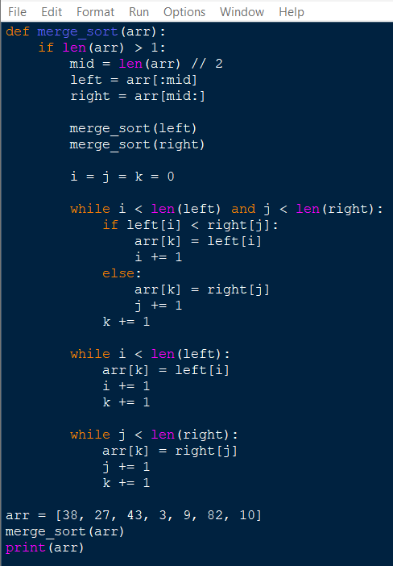

OUTPUT:

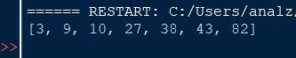

Experiment 7: Quick Sort

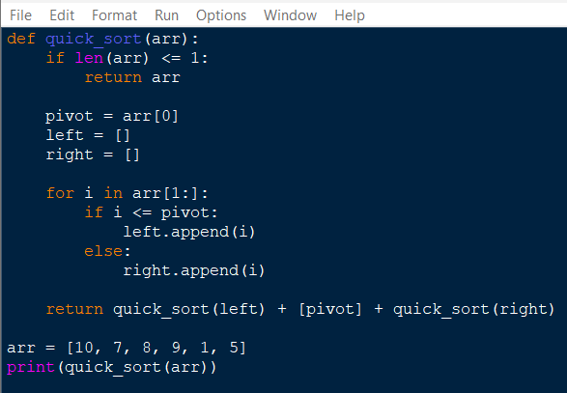

OUTPUT:

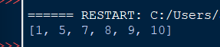

Experiment 8: Tower of Hanoi

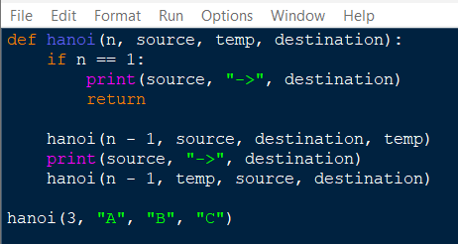

OUTPUT:

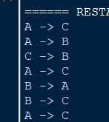

Experiment 9: GCD (Euclidean Algorithm)
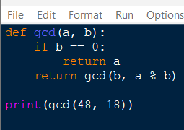

OUTPUT:

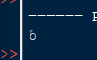

Experiment 10: Insertion Sort

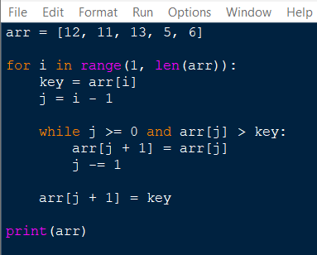

OUTPUT:

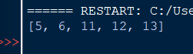

Experiment 11: Heap Sort

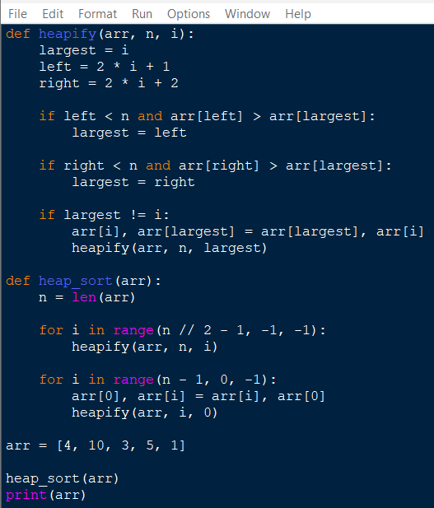

OUTPUT:

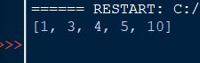

Experiment 12: Counting Inversions

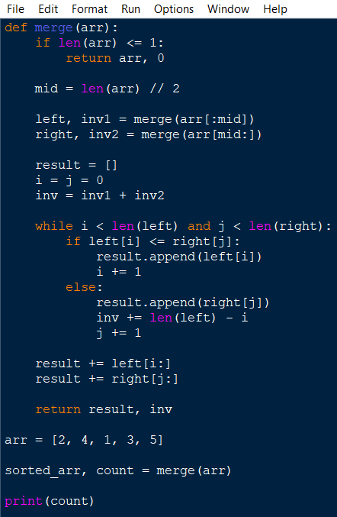

OUTPUT:

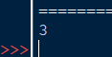

Experiment 13: Maximum Subarray Sum
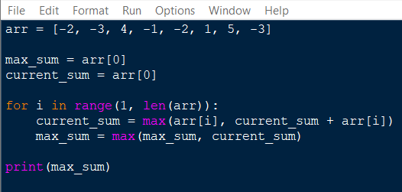

OUTPUT:

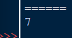

Experiment 14: Exponentiation
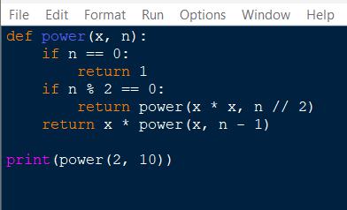

OUTPUT:

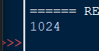

Experiment 15: Closest Pair of Points
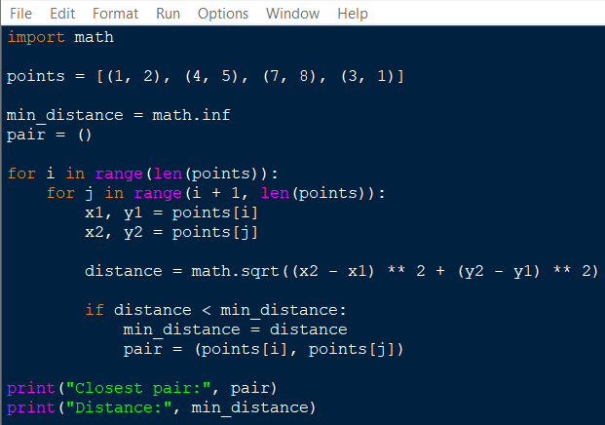

OUTPUT:
